DeSimone_MS64060_Assignment 4

Heather DeSimone

3/19/2022

##First I have loaded in my data frame and called a summary of the information.

df.original=read.csv("C:/Users/hdesi/Desktop/MBA/Machine Learning/Pharmaceuticals.csv")  
df.original.names.numerical=read.csv("C:/Users/hdesi/Desktop/MBA/Machine Learning/Pharmaceuticals.csv")[,c(1:11)]  
df=read.csv("C:/Users/hdesi/Desktop/MBA/Machine Learning/Pharmaceuticals.csv")[,c(3:11)]  
library(ISLR)

## Warning: package 'ISLR' was built under R version 4.1.1

library(dplyr)

##   
## Attaching package: 'dplyr'

## The following objects are masked from 'package:stats':  
##   
## filter, lag

## The following objects are masked from 'package:base':  
##   
## intersect, setdiff, setequal, union

library(tidyverse)

## Warning: package 'tidyverse' was built under R version 4.1.3

## -- Attaching packages --------------------------------------- tidyverse 1.3.1 --

## v ggplot2 3.3.5 v purrr 0.3.4  
## v tibble 3.1.2 v stringr 1.4.0  
## v tidyr 1.1.4 v forcats 0.5.1  
## v readr 2.1.2

## Warning: package 'ggplot2' was built under R version 4.1.2

## Warning: package 'tidyr' was built under R version 4.1.2

## Warning: package 'readr' was built under R version 4.1.3

## Warning: package 'stringr' was built under R version 4.1.2

## Warning: package 'forcats' was built under R version 4.1.3

## -- Conflicts ------------------------------------------ tidyverse_conflicts() --  
## x dplyr::filter() masks stats::filter()  
## x dplyr::lag() masks stats::lag()

library(factoextra)

## Warning: package 'factoextra' was built under R version 4.1.3

## Welcome! Want to learn more? See two factoextra-related books at https://goo.gl/ve3WBa

set.seed(123)  
summary(df)

## Market_Cap Beta PE_Ratio ROE   
## Min. : 0.41 Min. :0.1800 Min. : 3.60 Min. : 3.9   
## 1st Qu.: 6.30 1st Qu.:0.3500 1st Qu.:18.90 1st Qu.:14.9   
## Median : 48.19 Median :0.4600 Median :21.50 Median :22.6   
## Mean : 57.65 Mean :0.5257 Mean :25.46 Mean :25.8   
## 3rd Qu.: 73.84 3rd Qu.:0.6500 3rd Qu.:27.90 3rd Qu.:31.0   
## Max. :199.47 Max. :1.1100 Max. :82.50 Max. :62.9   
## ROA Asset_Turnover Leverage Rev_Growth   
## Min. : 1.40 Min. :0.3 Min. :0.0000 Min. :-3.17   
## 1st Qu.: 5.70 1st Qu.:0.6 1st Qu.:0.1600 1st Qu.: 6.38   
## Median :11.20 Median :0.6 Median :0.3400 Median : 9.37   
## Mean :10.51 Mean :0.7 Mean :0.5857 Mean :13.37   
## 3rd Qu.:15.00 3rd Qu.:0.9 3rd Qu.:0.6000 3rd Qu.:21.87   
## Max. :20.30 Max. :1.1 Max. :3.5100 Max. :34.21   
## Net_Profit_Margin  
## Min. : 2.6   
## 1st Qu.:11.2   
## Median :16.1   
## Mean :15.7   
## 3rd Qu.:21.1   
## Max. :25.5

df <- scale(df) #z-score  
distance <- get_dist(df)  
fviz_dist(distance)

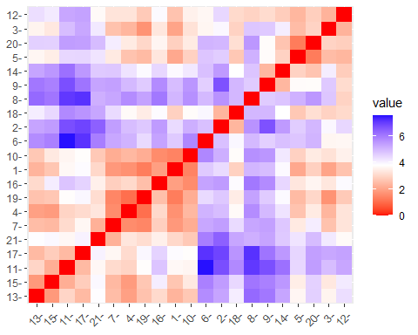 ##Will try k=4 first since 4 is the median distance shown in the above graph ##Will first use 25 restarts as it seems to be a typical number of random centroids to start with (based on the internet community)

k4 <- kmeans(df, centers = 4, nstart = 25)  
k4$centers

## Market_Cap Beta PE_Ratio ROE ROA Asset_Turnover  
## 1 1.69558112 -0.1780563 -0.1984582 1.2349879 1.3503431 1.153164e+00  
## 2 -0.03142211 -0.4360989 -0.3172485 0.1950459 0.4083915 1.729746e-01  
## 3 -0.82617719 0.4775991 -0.3696184 -0.5631589 -0.8514589 -9.994088e-01  
## 4 -0.52462814 0.4451409 1.8498439 -1.0404550 -1.1865838 1.480297e-16  
## Leverage Rev_Growth Net_Profit_Margin  
## 1 -0.4680782 0.4671788 0.5912425  
## 2 -0.2744931 -0.7041516 0.5569544  
## 3 0.8502201 0.9158889 -0.3319956  
## 4 -0.3443544 -0.5769454 -1.6095439

k4$size

## [1] 4 8 6 3

## 4, 8, 6, 3  
  
##21 data points total so lets look at where the 1st, last, and middle data points are   
k4$cluster[1] ##cluster 2

## [1] 2

k4$cluster[10] ##cluster 2

## [1] 2

k4$cluster[21] ##cluster 2

## [1] 2

fviz_cluster(k4, data = df) ##Visual

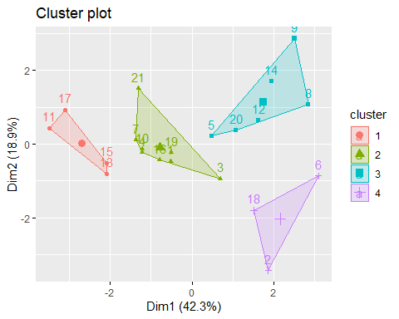 ##Lets see what happens with k=5

k5 <- kmeans(df, centers = 5, nstart = 25)  
k5$centers

## Market_Cap Beta PE_Ratio ROE ROA Asset_Turnover  
## 1 -0.76022489 0.2796041 -0.47742380 -0.7438022 -0.8107428 -1.2684804  
## 2 -0.43925134 -0.4701800 2.70002464 -0.8349525 -0.9234951 0.2306328  
## 3 -0.87051511 1.3409869 -0.05284434 -0.6184015 -1.1928478 -0.4612656  
## 4 -0.03142211 -0.4360989 -0.31724852 0.1950459 0.4083915 0.1729746  
## 5 1.69558112 -0.1780563 -0.19845823 1.2349879 1.3503431 1.1531640  
## Leverage Rev_Growth Net_Profit_Margin  
## 1 0.06308085 1.5180158 -0.006893899  
## 2 -0.14170336 -0.1168459 -1.416514761  
## 3 1.36644699 -0.6912914 -1.320000179  
## 4 -0.27449312 -0.7041516 0.556954446  
## 5 -0.46807818 0.4671788 0.591242521

k5$size

## [1] 4 2 3 8 4

## 4, 2, 3, 8, 4  
  
##21 data points total so lets look at where the 1st, last, and middle data points are   
k5$cluster[1] ##cluster 4

## [1] 4

k5$cluster[10] ##cluster 4

## [1] 4

k5$cluster[21] ##cluster 4

## [1] 4

##These data points are all falling in the same bucket - close together  
  
fviz_cluster(k5, data = df) ##Visual

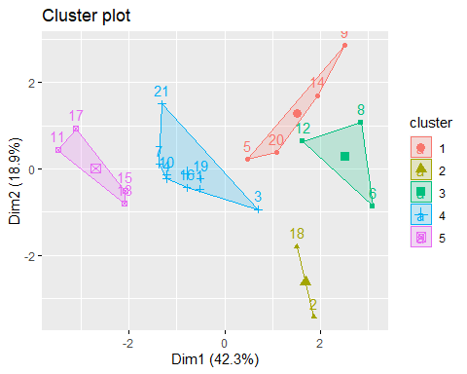

##Lets see what happens with k=3

k3 <- kmeans(df, centers = 3, nstart = 25)  
k3$centers

## Market_Cap Beta PE_Ratio ROE ROA Asset_Turnover  
## 1 0.6733825 -0.3586419 -0.2763512 0.6565978 0.8344159 0.4612656  
## 2 -0.6125361 0.2698666 1.3143935 -0.9609057 -1.0174553 0.2306328  
## 3 -0.8261772 0.4775991 -0.3696184 -0.5631589 -0.8514589 -0.9994088  
## Leverage Rev_Growth Net_Profit_Margin  
## 1 -0.3331068 -0.2902163 0.6823310  
## 2 -0.3592866 -0.5757385 -1.3784169  
## 3 0.8502201 0.9158889 -0.3319956

k3$size

## [1] 11 4 6

## 11, 4, 6  
  
##21 data points total so lets look at where the 1st, last, and middle data points are   
k3$cluster[1] ##cluster 1

## [1] 1

k3$cluster[10] ##cluster 1

## [1] 1

k3$cluster[21] ##cluster 1

## [1] 1

##These data points are all falling in the same bucket - close together  
  
fviz_cluster(k3, data = df) ##Visual

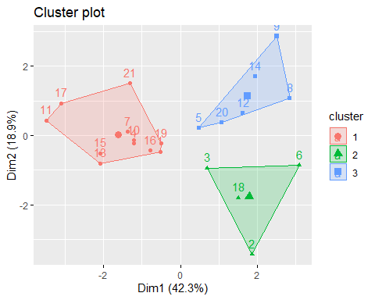 ##So far it looks like k=4 is the best option as it disperses the data somewhat evenly without splitting the data too drastically (a cluster of 1 or 2 observations doesn’t seem to be helpful)

fviz_nbclust(df, kmeans, method = "wss")

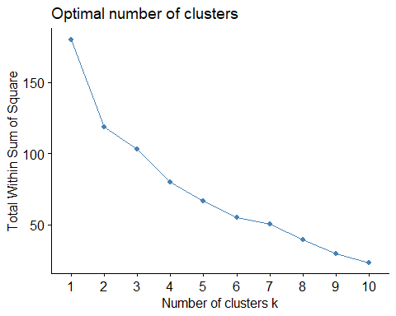 ##Based on the elbow method graph, it looks like K = 4, 5, or 6 is the optimal number of clusters

fviz_nbclust(df, kmeans, method = "silhouette")

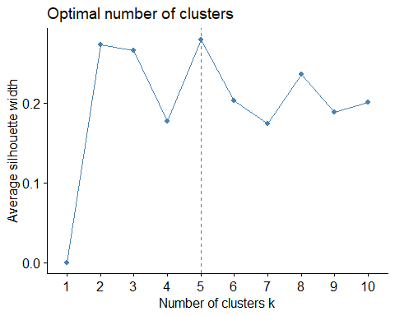 ##Based on the silhouette method, K=5 is the optimal number of clusters. We will use k=5 ##I will use k=5 and now use the manhattan distance for clustering the data

library(flexclust)

## Warning: package 'flexclust' was built under R version 4.1.3

## Loading required package: grid

## Loading required package: lattice

## Loading required package: modeltools

## Warning: package 'modeltools' was built under R version 4.1.1

## Loading required package: stats4

set.seed(123)  
k5.manhattan = kcca(df, k=5, kccaFamily("kmedians"))  
k5

## K-means clustering with 5 clusters of sizes 4, 2, 3, 8, 4  
##   
## Cluster means:  
## Market_Cap Beta PE_Ratio ROE ROA Asset_Turnover  
## 1 -0.76022489 0.2796041 -0.47742380 -0.7438022 -0.8107428 -1.2684804  
## 2 -0.43925134 -0.4701800 2.70002464 -0.8349525 -0.9234951 0.2306328  
## 3 -0.87051511 1.3409869 -0.05284434 -0.6184015 -1.1928478 -0.4612656  
## 4 -0.03142211 -0.4360989 -0.31724852 0.1950459 0.4083915 0.1729746  
## 5 1.69558112 -0.1780563 -0.19845823 1.2349879 1.3503431 1.1531640  
## Leverage Rev_Growth Net_Profit_Margin  
## 1 0.06308085 1.5180158 -0.006893899  
## 2 -0.14170336 -0.1168459 -1.416514761  
## 3 1.36644699 -0.6912914 -1.320000179  
## 4 -0.27449312 -0.7041516 0.556954446  
## 5 -0.46807818 0.4671788 0.591242521  
##   
## Clustering vector:  
## [1] 4 2 4 4 1 3 4 3 1 4 5 3 5 1 5 4 5 2 4 1 4  
##   
## Within cluster sum of squares by cluster:  
## [1] 12.791257 2.803505 15.595925 21.879320 9.284424  
## (between_SS / total_SS = 65.4 %)  
##   
## Available components:  
##   
## [1] "cluster" "centers" "totss" "withinss" "tot.withinss"  
## [6] "betweenss" "size" "iter" "ifault"

##Based on our two models, it seems that the firms in cluster 5 are the top performers.

##Now I will examine 2 specific attributes - ROE & ROA - The higher the ROE & ROA are, the better the firm is performing and will probably continue to perform well.

ROE.ROA.DF=read.csv("C:/Users/hdesi/Desktop/MBA/Machine Learning/Pharmaceuticals.csv")[,c(6,7)]  
set.seed(123)  
summary(ROE.ROA.DF)

## ROE ROA   
## Min. : 3.9 Min. : 1.40   
## 1st Qu.:14.9 1st Qu.: 5.70   
## Median :22.6 Median :11.20   
## Mean :25.8 Mean :10.51   
## 3rd Qu.:31.0 3rd Qu.:15.00   
## Max. :62.9 Max. :20.30

##Looking for the best k value

ROE.ROA.DF <- scale(ROE.ROA.DF) #z-score  
distance <- get_dist(ROE.ROA.DF)  
fviz_dist(distance)

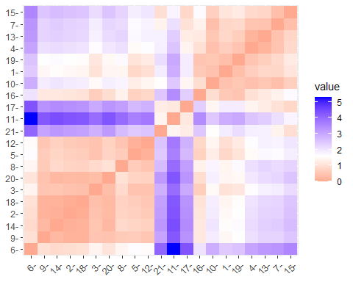

fviz_nbclust(ROE.ROA.DF, kmeans, method = "wss")##elbow

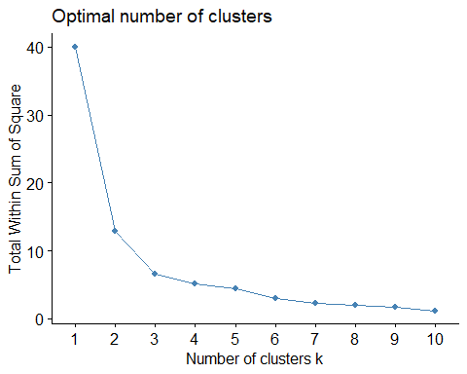

fviz_nbclust(ROE.ROA.DF, kmeans, method = "silhouette")

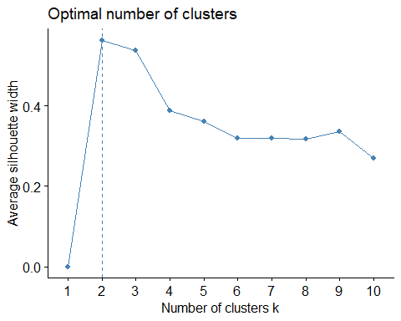 ##Based on both methods, k=2 or k=3 is optimal - we will use 3 as 2 is too insignificant

ROA.ROE.PERFORMANCE <- kmeans(ROE.ROA.DF, centers = 3, nstart = 25)  
ROA.ROE.PERFORMANCE$centers

## ROE ROA  
## 1 1.9006613 1.3378151  
## 2 0.1900740 0.6456412  
## 3 -0.7222576 -0.9178575

ROA.ROE.PERFORMANCE$size

## [1] 3 8 10

## 3, 8, 10  
  
fviz_cluster(ROA.ROE.PERFORMANCE, data = ROE.ROA.DF) ##Visual

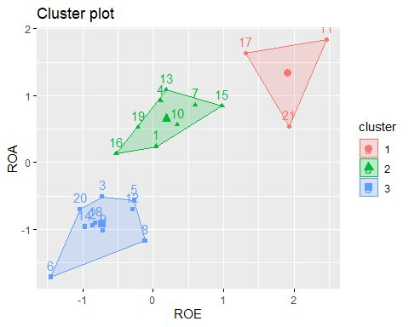 ##Firms in cluster 1 have the highest ROA and ROE - data points 11,17, & 21 ##Best: 11 - GlaxoSmithKline plc ##Also High Performers: 17 - Pfizer Inc 21 - Wyeth

##We will examine the market capitalization and the price to earnings ratio to determine the worth of a firm (in terms of investing).

FIRM.WORTH.DF=read.csv("C:/Users/hdesi/Desktop/MBA/Machine Learning/Pharmaceuticals.csv")[,c(3,5)]  
set.seed(123)  
summary(FIRM.WORTH.DF)

## Market_Cap PE_Ratio   
## Min. : 0.41 Min. : 3.60   
## 1st Qu.: 6.30 1st Qu.:18.90   
## Median : 48.19 Median :21.50   
## Mean : 57.65 Mean :25.46   
## 3rd Qu.: 73.84 3rd Qu.:27.90   
## Max. :199.47 Max. :82.50

##Looking for the best k value

FIRM.WORTH.DF <- scale(FIRM.WORTH.DF) #z-score  
distance <- get_dist(FIRM.WORTH.DF)  
fviz_dist(distance)

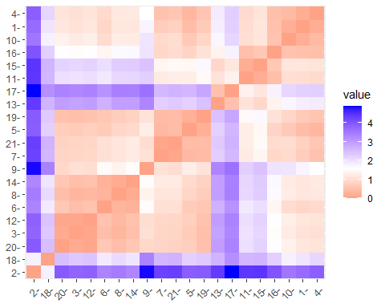

fviz_nbclust(FIRM.WORTH.DF, kmeans, method = "wss")##elbow

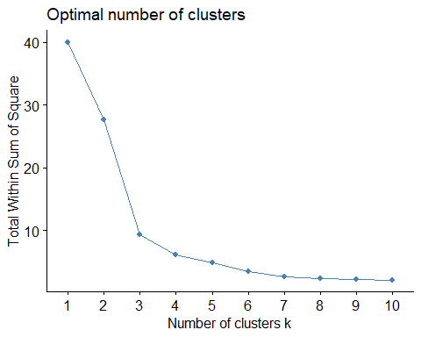

fviz_nbclust(FIRM.WORTH.DF, kmeans, method = "silhouette")

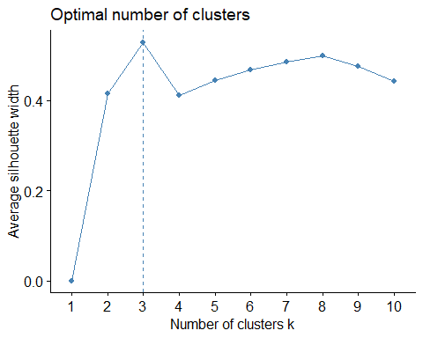 ##Based on both methods, k=3 is optimal

FIRM.WORTH <- kmeans(FIRM.WORTH.DF, centers = 3, nstart = 25)  
FIRM.WORTH$centers

## Market_Cap PE_Ratio  
## 1 1.4895591 -0.2061221  
## 2 -0.4692352 -0.3121028  
## 3 -0.4392513 2.7000246

FIRM.WORTH$size

## [1] 5 14 2

## 5, 14, 2  
  
fviz_cluster(FIRM.WORTH, data = FIRM.WORTH.DF) ##Visual

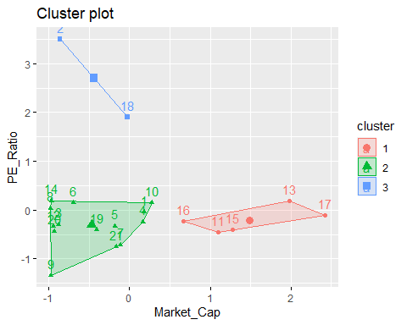 ##A high PE Ratio can be seen as good or bad, depending. Since these are established firms rather than a startup, we want a lower PE Ratio indicating that we are not overpaying for the value of the stock. A higher market capitalization is always better ##The firm with the best stock value (you should invest) is 13 - Johnson & Johnson (in my opinion) ##Options in cluster 1 have the best stock value

##Are other attributes are valuable to look at, but the 4 I have chosen to concentrate on will lead to the best odds of high performance if stock is purchased. Looking into the other attributes may cloud the waters.

##If only one stock can be purchased than the best option would be Pfizer Inc who is located in high performing ares in their clusters of both segmentations.